**1.Finding Factorial of a number**

n = int(input("Enter a number:"))

result = 1

for i in range(n,0,-1):

result = result*i

print("The factorial of",n,"is: ",result)

**OUTPUT:**

Enter a number: 6

The factorial of 6 is: 720

Enter a number: 5

The factorial of 5 is: 120

**2.To check Prime Number**

num = int(input("Enter a number: "))

if num > 1:

for i in range(2,num):

if(num%i)==0:

print(num,"is not a prime number")

break

else:

print(num,"is a prime number")

**OUTPUT:**

Enter a number: 15

15 is not a prime number

Enter a number: 13

13 is a prime number

**3.Write a python program to get the length of the first two lists of a given list.**

list1=[[1,2,3,4,5],"Python Programming","HTML"]

print("Original list:")

print(list1)

print("Length of the first two lists in the given list:")

len1 = len(list1[0])

len2 = len(list1[1])

print(len1)

print(len2)

**OUTPUT:**

Original list:

[[1, 2, 3, 4, 5], 'Python Programming', 'HTML']

Length of the first two lists in the given list:

5

18

**1.write a python program to create a list containing string, numbers, vectors and a logical values**

list_data = list(("Python","PHP",(5,7,9,11),True, 125.17, 75.83))

print("Data of the list:")

print(list_data)

**2.write a python program to merge two given lists into one list :**

n1 = (1,2,3)

c1 = ("Red", "Green", "Black")

print("Original lists:")

print(n1)

print(c1)

mlist = n1 + c1

print("New merged lists:")

print(mlist)

**OUTPUT :**



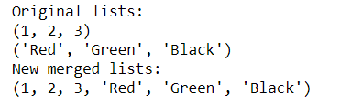

**KNN ALGORITHM**

import numpy as np

import pandas as pd

import matplotlib.pyplot as plt

data = pd.read_csv("ads.csv")

data.head()

data.isnull().any()

x=data.iloc[:,1:4].values

y=data.iloc[:,4:5].values

x[:5]

y[:5]

from sklearn.preprocessing import LabelEncoder

lb = LabelEncoder()

x[:,0] **=** lb.fit_transform(x[:,0])

x[:5]

from sklearn.model_selection import train_test_split as tts

x_train,x_test,y_train,y_test = tts(x, y, test_size = 0.1,random_state=0)

from sklearn.preprocessing import MinMaxScaler

sc = MinMaxScaler()

x_train = sc.fit_transform(x_train)

x_test = sc.transform(x_test)

from sklearn.neighbors import KNeighborsClassifier

knn = KNeighborsClassifier ( n_neighbors = 5 , p = 2 )

knn.fit(x_train,y_train)

y_pred=knn.predict(x_test)

y_pred

y_test

from sklearn.metrics import accuracy_score

accuracy_score(y_test,y_pred)

from sklearn.metrics import confusion_matrix

import sklearn.metrics as metrics

fpr, tpr ,threshold **=** metrics.roc_curve(y_test,y_pred)

roc_auc **=** metrics.auc(fpr,tpr)

roc_auc

plt.plot(fpr,tpr)

plt.xlim([0,1])

plt.ylim([0,1])

plt.style.use("fivethirtyeight")

**OUTPUT:**

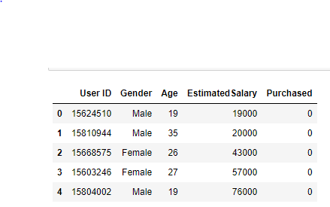

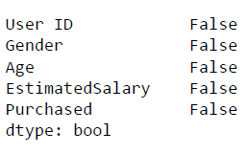

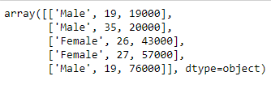

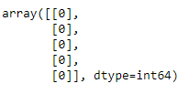

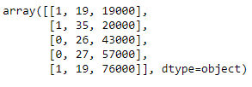

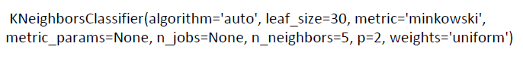



array([[0],

[0],

[0],

[0],

[0],

[0],

[0],

[1],

[0],

[0],

[0],

[0],

[0],

[0],

[0],

[0],

[0],

[0],

[1],

[0],

[0],

[1],

[0],

[1],

[0],

[1],

[0],

[0],

[0],

[0],

[0],

[1],

[1],

[0],

[0],

[0],

[0],

[0],

[0],

[1]], dtype=int64)

0.925 19

0.90625

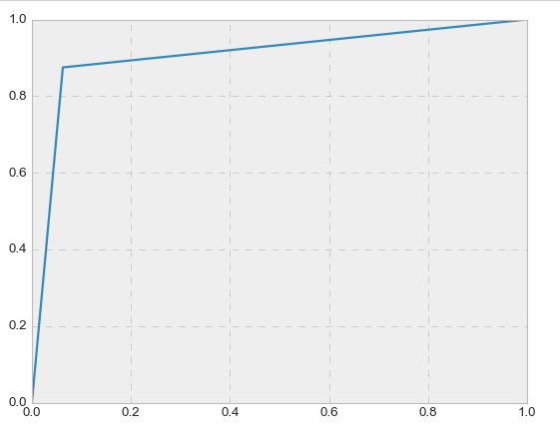

**Decision Tree**

import numpy as np

import pandas as pd

import matplotlib.pyplot as plt

data = pd.read_csv("ads.csv")

data.head()

data.isnull().any()

x = data.iloc[:,1:4].values

y = data.iloc[:,4:5].values

x

y[:10]

from sklearn.preprocessing import LabelEncoder

lb = LabelEncoder()

x[:,0] = lb.fit_transform(x[:,0])

x

from sklearn.model_selection import train_test_split as tts

x_train,x_test,y_train,y_test = tts(x, y, test_size = 0.1,random_state=0)

x_train

x_test[:10]

from sklearn.tree import DecisionTreeClassifier

dt = DecisionTreeClassifier(criterion='entropy')

dt.fit(x_train,y_train)

y_pred = dt.predict(x_test)

y_pred

from sklearn.metrics import accuracy_score

accuracy_score(y_test,y_pred)

from sklearn.metrics import confusion_matrix

confusion_matrix(y_test,y_pred)

import sklearn.metrics as metrics

fpr, tpr ,threshold = metrics.roc_curve(y_test,y_pred)

roc_auc = metrics.auc(fpr,tpr)

roc_auc

plt.plot(fpr,tpr)

plt.xlim([0,1])

plt.ylim([0,1])

plt.style.use("dark_background")

from sklearn.tree import export_graphviz

export_graphviz(dt, out_file ='tree.dot',

feature_names = ["Gender","Age","Salary"], class_names = ['0','1'],

rounded = True, proportion = False, precision = 2, filled = True)

!pip install pydotplus

!conda install graphviz

!dot tree.dot -Tpng -o image.png

**OUTPUT:**





array([[0],

[0],

[0],

[0], 24

[0],

[0],

[0],

[1],

[0],

[0]], dtype=int64)

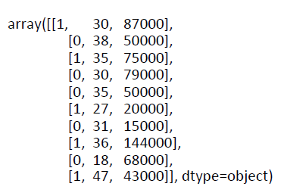

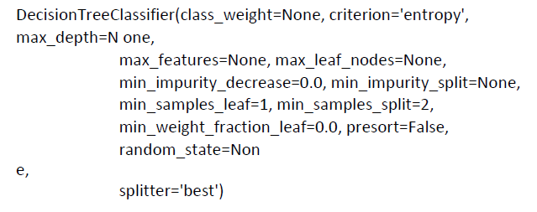

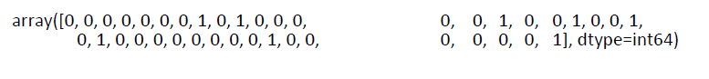

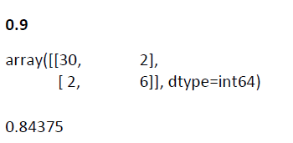

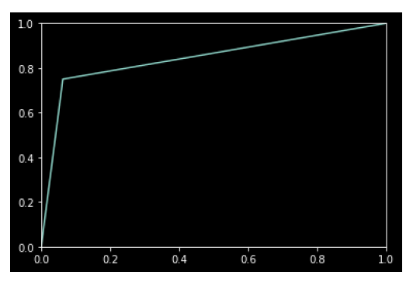

**Random Forest Classification**

import numpy as np

import matplotlib.pyplot as plt

import pandas as pd

dataset = pd.read_csv("ads.csv")

dataset.head()

dataset.isnull().any()

x = dataset.iloc[:, 1:4].values y = dataset.iloc[:, 4].values

x[:5]

y[:5]

from sklearn.preprocessing import LabelEncoder lb=LabelEncoder() x[:,0]=lb.fit_transform(x[:,0])

x[:5]

from sklearn.model_selection import train_test_split

x_train, x_test, y_train, y_test = train_test_split(x, y, test_size = 0.1, random_state = 0

from sklearn.ensemble import RandomForestClassifier

rf=RandomForestClassifier(n_estimators=10000,criterion='entropy')

rf.fit(x_train,y_train)

y_pred=rf.predict(x_test)

from sklearn.metrics import accuracy_score

print("Accuracy Score: ",accuracy_score(y_test,y_pred)*100,"%")

from sklearn.metrics import confusion_matrix

pd.DataFrame(confusion_matrix(y_test,y_pred),columns=["Prediction -0","Prediction -1"],inde

import sklearn.metrics as metrics

fpr, tpr, threshold = metrics.roc_curve(y_test, y_pred) roc_auc = metrics.auc(fpr, tpr)

print("AUC:",roc_auc)

plt.title('Receiver Operating Characteristic')

plt.plot(fpr, tpr, 'b', label **=** 'AUC = %0.2f' **%** roc_auc)

plt.legend(loc **=** 'lower right')

plt.xlim([0, 1])

plt.ylim([0, 1])

plt.ylabel('True Positive Rate')

plt.xlabel('False Positive Rate')

plt.show()

**OUTPUT:**

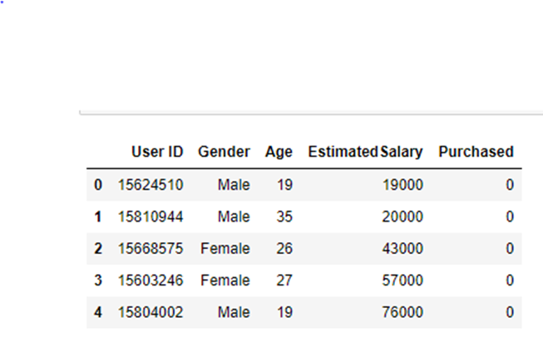





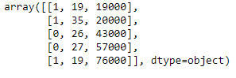

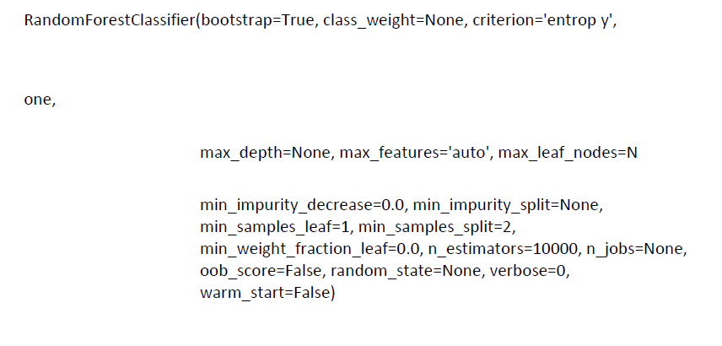

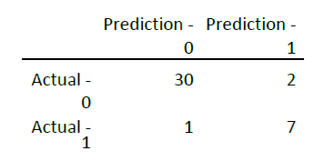





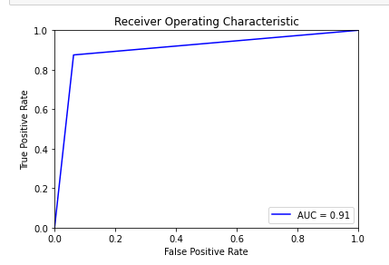

**Decision Tree**

import numpy as np

import pandas as pd

import matplotlib.pyplot as plt

data = pd.read_csv("ads.csv")

data.head()

data.isnull().any()

x = data.iloc[:,1:4].values y = data.iloc[:,4:5].values

x

y[:10]

from sklearn.preprocessing import LabelEncoder lb = LabelEncoder()

x[:,0] = lb.fit_transform(x[:,0])

x

from sklearn.model_selection import train_test_split as tts x_train,x_test,y_train,y_test = tts(x, y, test_size = 0.1,random_state=0)

x_train

x_test[:10]

from sklearn.tree import DecisionTreeClassifier

dt = DecisionTreeClassifier(criterion='entropy')

dt.fit(x_train,y_train)

y_pred = dt.predict(x_test)

y_pred

from sklearn.metrics import accuracy_score

accuracy_score(y_test,y_pred)

from sklearn.metrics import confusion_matrix

confusion_matrix(y_test,y_pred)

import sklearn.metrics as metrics

fpr, tpr ,threshold = metrics.roc_curve(y_test,y_pred)

roc_auc = metrics.auc(fpr,tpr)

roc_auc

plt.plot(fpr,tpr)

plt.xlim([0,1])

plt.ylim([0,1])

plt.style.use("ggplot")

from sklearn.tree import export_graphviz

export_graphviz(dt, out_file ='tree.dot',

feature_names = ["Gender","Age","Salary"], class_names = ['0','1'],

rounded = True, proportion = False, precision = 2, filled = True)

!pip install pydotplus

!conda install graphviz

!dot tree.dot -Tpng -o image.png

**OUTPUT:**

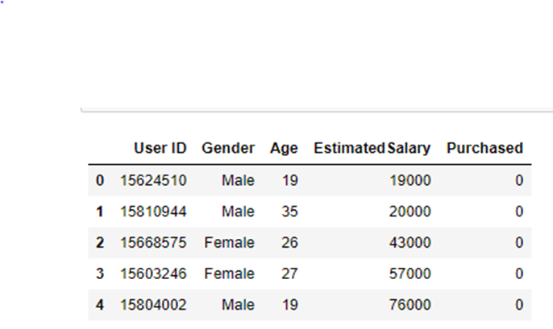



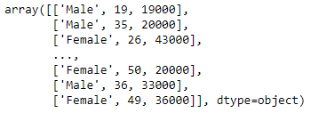

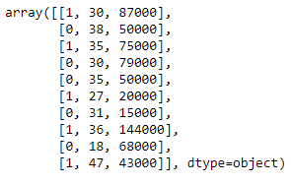

**C:\Users\Admin\OneDrive\Pictures\ML lab 6th ex\5.PNG**

**C:\Users\Admin\OneDrive\Pictures\ML lab 6th ex\6.PNG**

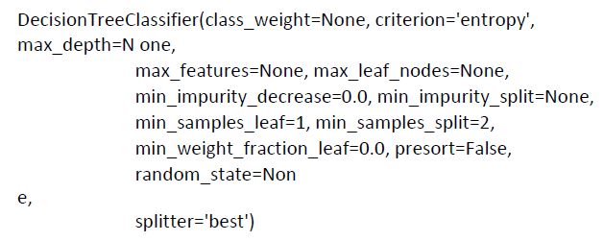

**C:\Users\Admin\OneDrive\Pictures\ML lab 6th ex\8 (2).PNG**

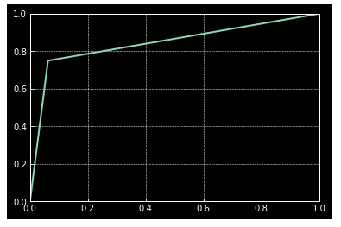

**Artificial Neural Network**

import numpy as np

import matplotlib.pyplot as plt

import pandas as pd

dataset = pd.read_csv('Churn_Modelling.csv')

dataset.head()

dataset.isnull().any()

x = dataset.iloc[:, 3:13].values

y = dataset.iloc[:, 13].values

x[:5]

y[:5]

from sklearn.preprocessing import LabelEncoder, OneHotEncoder

labelencoder_X_1 = LabelEncoder()

x[:, 1] = labelencoder_X_1.fit_transform(x[:, 1])

labelencoder_X_2 = LabelEncoder()

x[:, 2] = labelencoder_X_2.fit_transform(x[:, 2])

onehotencoder = OneHotEncoder(categorical_features = [1])

x = onehotencoder.fit_transform(x).toarray()

x = x[:, 1:]

from sklearn.model_selection import train_test_split

x_train, x_test, y_train, y_test = train_test_split(x, y, test_size = 0.2, random_state = 0)

from sklearn.preprocessing import MinMaxScaler

sc=MinMaxScaler()

x_train=sc.fit_transform(x_train)

x_test=sc.transform(x_test)

from keras.models import Sequential

from keras.layers import Dense

model=Sequential() model.add(Dense(input_dim=11,init="random_uniform",activation="relu",output_dim=20)) model.add(Dense(init="random_uniform",activation="relu",output_dim=15)) model.add(Dense(init="random_uniform",activation="sigmoid",output_dim=1)) model.compile(optimizer="adam",loss="binary_crossentropy",metrics=["accuracy"]) model.fit(x_train,y_train,batch_size=32,epochs=100)

y_pred=model.predict(x_test)

y_pred

y_pred=y_pred>0.5

y_pred

from sklearn.metrics import accuracy_score

print("Accuracy score",accuracy_score(y_test,y_pred)*100,"%")

**OUTPUT:**

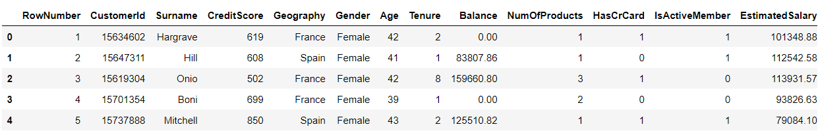

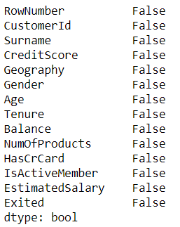

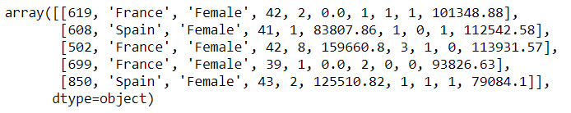



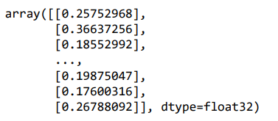

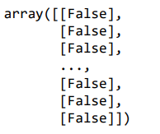



**K-Means Algorithm**

import numpy as np

import matplotlib.pyplot as plt

import pandas as pd

dataset = pd.read_csv('Mall_Customers.csv')

dataset.head()

dataset.isnull().any()

x = dataset.iloc[:,[3,4]].values

x[:5]

from sklearn.cluster import KMeans

wcss = []

for i in range(1,11):

kmeans = KMeans(n_clusters = i,init = 'k-means++' , max_iter = 300, n_init = 10)

kmeans.fit(x)

wcss.append(kmeans.inertia_)

plt.plot(range(1,11),wcss)

plt.title('The Elbow Method')

plt.xlabel('Number of clusters')

plt.ylabel('WCSS')

plt.show()

kmeans = KMeans(n_clusters=5,init = 'k-means++' , max_iter = 300, n_init=10,random_state=0)

y_kmeans = kmeans.fit_predict(x)

y_kmeans[:5]

plt.scatter(x[y_kmeans == 0,0],x[y_kmeans == 0,1],s=100,c='red',label='cluster 1')

plt.scatter(x[y_kmeans == 1,0],x[y_kmeans == 1,1],s=100,c='blue',label='cluster 2')

plt.scatter(x[y_kmeans == 2,0],x[y_kmeans == 2,1],s=100,c='green',label='cluster 3')

plt.scatter(x[y_kmeans == 3,0],x[y_kmeans == 3,1],s=100,c='yellow',label='cluster 4')

plt.scatter(x[y_kmeans == 4,0],x[y_kmeans == 4,1],s=100,c='brown',label='cluster 5')

plt.scatter(kmeans.cluster_centers_[:,0],kmeans.cluster_centers_[:,1],s=300,c='black',label='centroids')

plt.title('Clusters of clients')

plt.xlabel("Annual Income in 1000 $")

plt.ylabel("Spending Score (1-1000")

plt.legend()

plt.show()

**OUTPUT:**

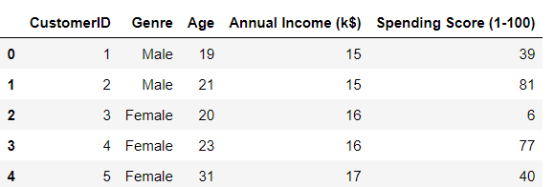

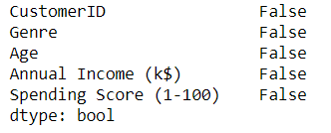

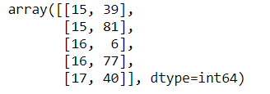

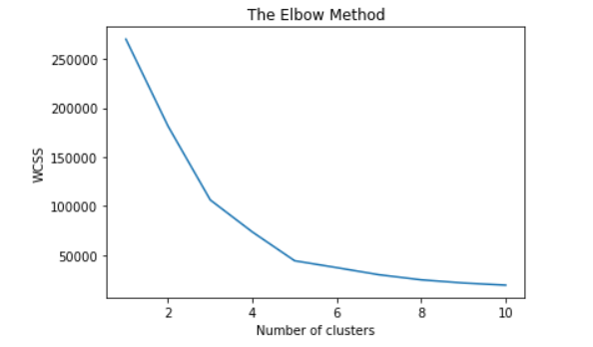



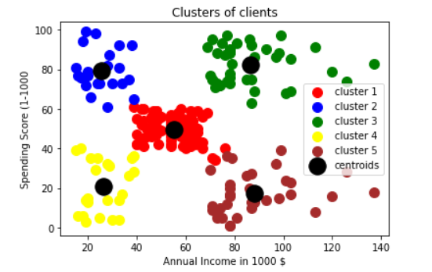

**Hierarchical Clustering**

import numpy as np

import matplotlib.pyplot as plt

import pandas as pd

dataset = pd.read_csv('Mall_Customers.csv')

x = dataset.iloc[:, [3, 4]].values

x[:5]

import scipy.cluster.hierarchy as sch

dendrogram = sch.dendrogram(sch.linkage(x, method = 'ward'))

plt.title('Dendrogram')

plt.xlabel('Customers')

plt.ylabel('Euclidean distances')

plt.show()

from sklearn.cluster import AgglomerativeClustering

hc = AgglomerativeClustering(n_clusters = 5, affinity = 'euclidean', linkage = 'ward')

y_hc = hc.fit_predict(x)

y_hc[:5]

plt.scatter(x[y_hc == 0, 0], x[y_hc == 0, 1], s = 100, c = 'red', label = 'Cluster 1')

plt.scatter(x[y_hc == 1, 0], x[y_hc == 1, 1], s = 100, c = 'blue', label = 'Cluster 2')

plt.scatter(x[y_hc == 2, 0], x[y_hc == 2, 1], s = 100, c = 'green', label = 'Cluster 3')

plt.scatter(x[y_hc == 3, 0], x[y_hc == 3, 1], s = 100, c = 'cyan', label = 'Cluster 4')

plt.scatter(x[y_hc == 4, 0], x[y_hc == 4, 1], s = 100, c = 'magenta', label = 'Cluster 5')

plt.title('Clusters of customers')

plt.xlabel('Annual Income (k$)')

plt.ylabel('Spending Score (1-100)')

plt.legend()

plt.show()

**OUTPUT:**

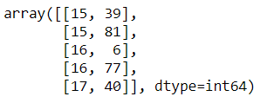

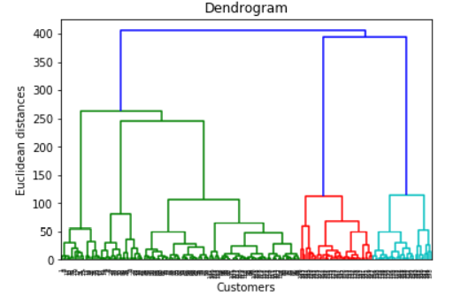



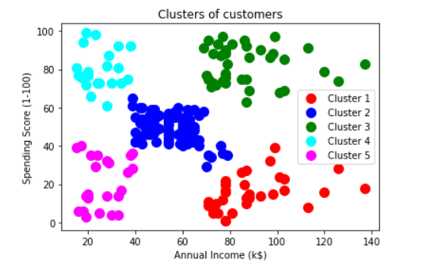

**Apriori Algorithm**

import numpy as np

import matplotlib.pyplot as plt

import pandas as pd

dataset = pd.read_csv('Market_Basket_Optimisation.csv',header = None)

dataset.head()

transactions = []

for i in range(0, 7501):

transactions.append([str(dataset.values[i,j]) for j in range(0, 20)])

from apyori import apriori

rules = apriori(transactions, min_support = 0.003, min_confidence = 0.2, min_lift = 3, min_right = 3)

results = list(rules)

results

**OUTPUT:**

